**CS Practical**

Name: Aditya Dang

Roll no.: 03

Class: XI-E

1.Write a Python program to swap two variables.

Code:

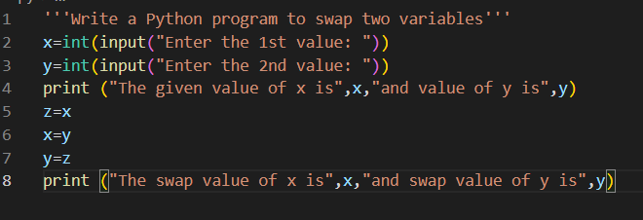

Output:

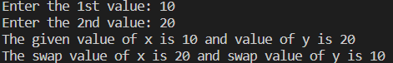

2. Write a Python program to input angles of a triangle and check whether triangle is valid or not.

Code:

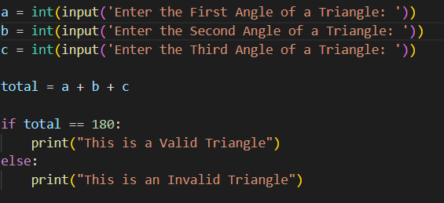

Output:

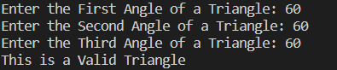 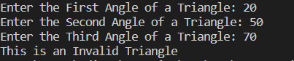

3. Write a Python program to input all sides of a triangle and check whether triangle is valid or not.

Code:

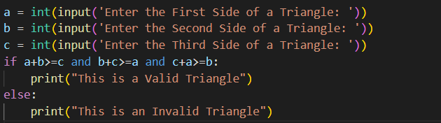

Output:

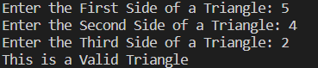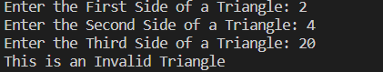

4. Write a Python program to check whether the triangle is equilateral, isosceles or scalene triangle.

Code:

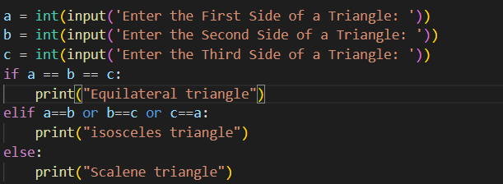

Output:

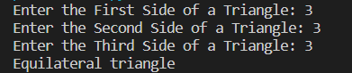 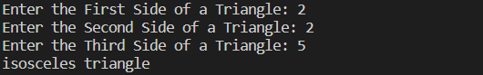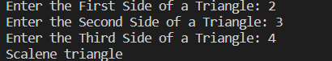

5. Write a [Python program to convert Celsius to Fahrenheit](https://www.javatpoint.com/python-convert-celsius-to-fahrenheit)

Code:

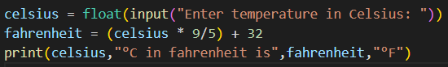

Output: 

6. Write a Python program to print all-natural numbers in reverse (from n to 1).

Code:

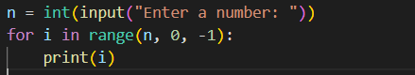

Output:

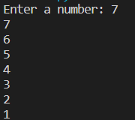

7. Write a Python program to print all alphabets from a to z.

Code:



Output:

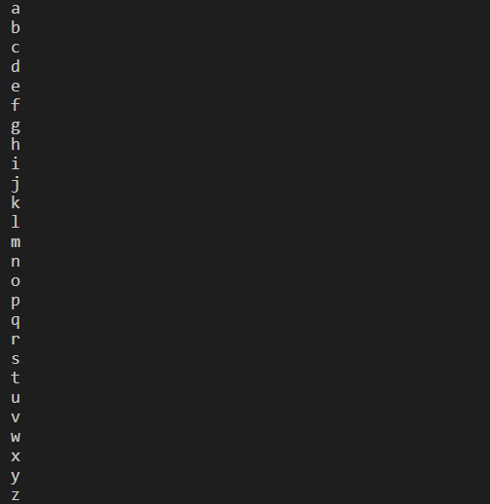

8. Write a Python program to print all even numbers between 1 to 100.

Code:



Output:

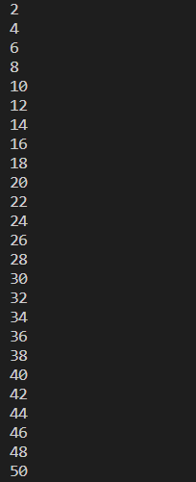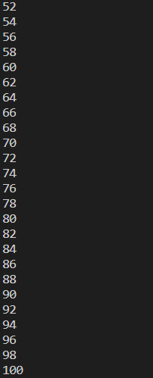

9. Write a Python program to print all odd number between 1 to 100.

Code:

 Output:

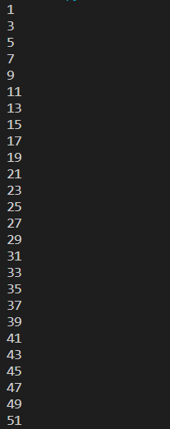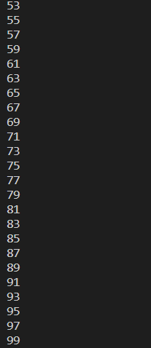

10. Write a Python program to find sum of all-natural numbers between 1 to n.

Code:

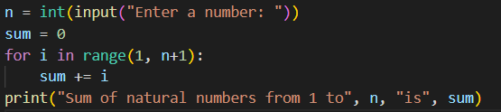

Output:



11. Write a Python program to find sum of all even numbers between 1 to n.

Code:

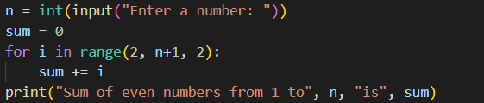

Output:



12. Write a Python program to length of the string without using len function

Code:

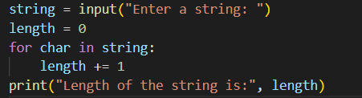

Output:



13. Write a Python program to count no of vowel in given string .

Code:

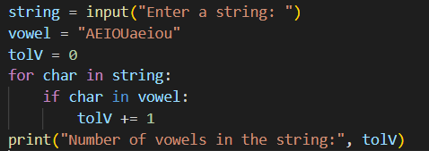

Output:



14.Write a Python program to print all prime number between 1 to 100.

Code:

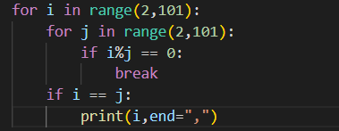

Output:



15. Write a Python program to print factorial of a given Number.

Code:

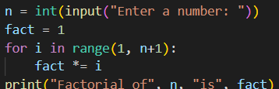

Output:



16. Write a Python program to print following pattern

10101

0101

010

10

1

Code:

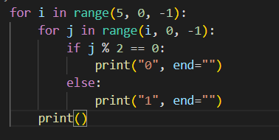

Output:

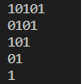

17. Write a Python program to print following pattern

1 2 3 4

1 2 3 4

1 2 3 4

1 2 3 4

Code:

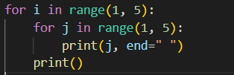

Output:

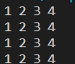

18. Write a Python program to print following pattern

1 2 3 4

1 2 3

1 2

1

Code:

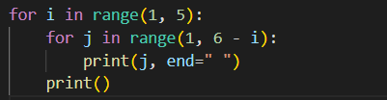

Output:

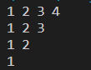

19. Write a Python program to print following pattern

A

A B

A B C

A B C D   
Code:

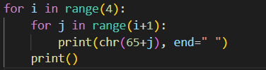

Output:

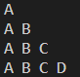

20. Write a Python program to print following pattern

10,9,8,7

6,5,4

3,2

1

Code:

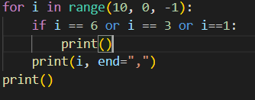

Output:

